Chapter 6: Interaction between organisms

6.1 All organisms are interdependent

Literacy support worksheet answers (pages 102–103)

Food chains & food webs

1 Use the diagram of the owl with the mouse inside its belly and the wheat inside the mouse to construct a food chain. Under each organism in the food chain, write whether they are a consumer or producer.

Wheat (producer) → mouse (consumer) → owl (consumer)

2 Could the Sun also be included in a food chain or food web?

The Sun could be included at the start of the food chain or web because the arrows in a food chain show the movement of energy. Alternatively, the Sun cannot be included in the food chain or web because the arrow would point to a producer, not a consumer.

3 Draw a diagram showing how food chains work using the following words (refer to Figure 6.4 to help you):

See example on page 103.

4 A food pyramid gives information about organisms and energy at each level of a food chain.

a What happens to the amount of energy as you move up the food chain?

The amount of energy decreases as you move up a food chain.

b What happens to the size of the organisms as you move up a food chain?

The size of the organisms increases as you move up a food chain.

c Can you think of an example where the size of the organism gets smaller as you move up a food chain?

Student responses will vary but could include the big cats, such as lions, which hunt larger animals, such as wildebeests.

WORD DETECTIVE

5 Mumbo-jumbo

a Use the marked letters to find the secret word (e.g. olusntoi = solution).

b Unscramble each of the clue words below to find the message.

Secret word: ENERGY

Message: A FOOD PYRAMID SHOWS ORGANISMS AT EACH LEVEL OF THE FOOD CHAIN

6.2 All organisms have a role in an ecosystem

Literacy support worksheet answers (pages 104–105)

Ecosystems – energy for life

1 Plants are producers that convert the Sun’s energy into food using photosynthesis. Using the information below, label the arrows on the diagram.

In most ecosystems, the Sun provides the energy for the producers. Producers use this energy during photosynthesis to change the Sun’s energy into food. During photosynthesis, the sunlight shines on the green leaf, where it converts carbon dioxide and water into sugar and oxygen.

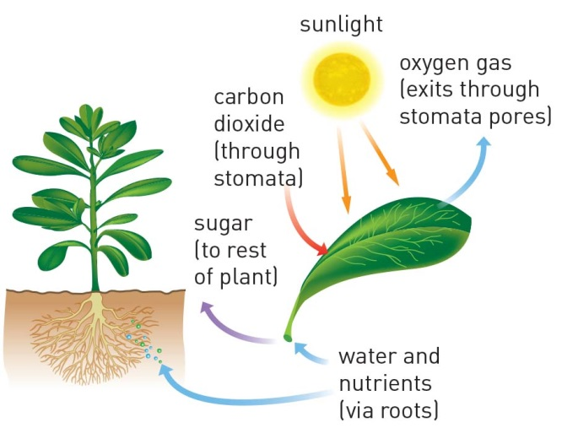

2 Fill in the examples in the flow diagram below.

Decomposers Examples: bacteria, fungi, slugs and worms

EAT

Consumers (carnivores) Examples: dragonflies and wedged-tailed eagles

EAT

Consumers (herbivores) Examples: nymphs, water beetles and fish

EAT

Producers (plants) Examples: Flowers, grasses and algae

USE

Photosynthesis During photosynthesis, the Sun shines on the green leaf where it converts: sunlight, carbon dioxide and water into energy

3 The cow in the image is in the process of being recycled by decomposers.

Fill in the flow chart and identify whether each living thing is a producer, consumer (herbivore), consumer (carnivore) or decomposer.

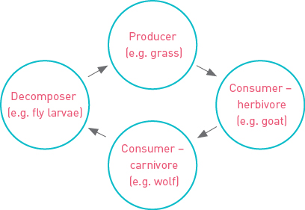

WORD DETECTIVE

4 Secret message

Use words from the student book to work out the secret message below:

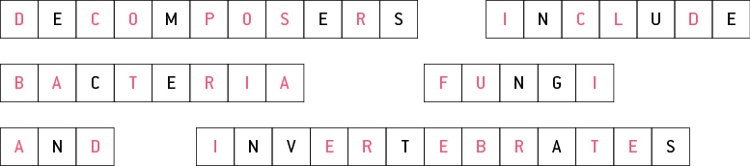

6.3 Food webs can be disrupted

Literacy support worksheet answers (pages 106–107)

Balance in the food web

1 The following observations were made last time I sat by a billabong:

• Nymphs, water beetles and fish were eating algae and water plants.

• Dragonflies were seen eating the water beetles and nymphs.

• European wasps were eating the nymphs and water beetles, and were attacking the dragonflies.

• A large black swan started feeding on the water plants, but also ate the nymphs and water beetles.

• A long-necked turtle also ate the water plants and water beetles.

• A huge wedged-tailed eagle swooped down and picked up the turtle from the water and started to eat it.

a Construct a food web from the information above. Draw the arrows from the European wasps in red.

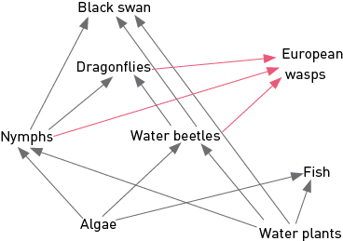

b What did the European wasps feed on?

The European wasps ate water beetles, nymphs and dragonflies.

c What would have normally eaten the organisms that the European wasps ate?

Normally, the dragonflies, black swam and long-necked turtle would have eaten the organisms the European wasps ate.

d Were there any predators of the European wasps?

No organisms were predators of the European wasps.

e How do you think the European wasps may change the billabong in the future? (Hint: Which animals may be missing next time?)

Water beetles and nymphs may be missing next time because of so many predators. Dragonflies may also be missing because of the wasps attacking them.

2 If a frog eats 104 insects in one week, how many insects does it eat in:

a one month?

One frog would eat 416 invertebrates.

b one year?

One frog would eat 5408 invertebrates.

c one day?

One frog would eat 15 invertebrates.

WORD DETECTIVE

3 Word search

Find the words listed, in the puzzle below.

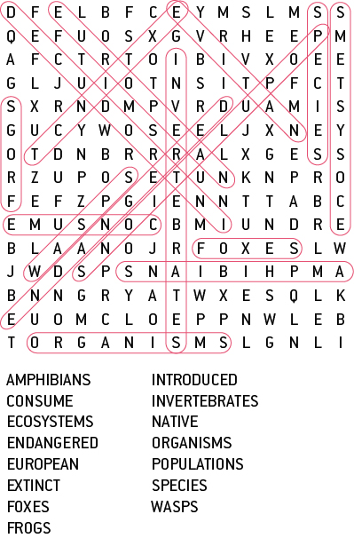

6.4 Human activity can affect local habitats

Literacy support worksheet answers (pages 108–109)

Habitat destruction

1 Label the diagram of the Amazon rainforest by completing the phrases below. Try to include more detail too.

• The trees have been cut down for…

• The land has been cleared for…

• The river is brown because…

• The burning trees cause…

• Pollution in this area comes from…

• The remaining habitat is under threat from…

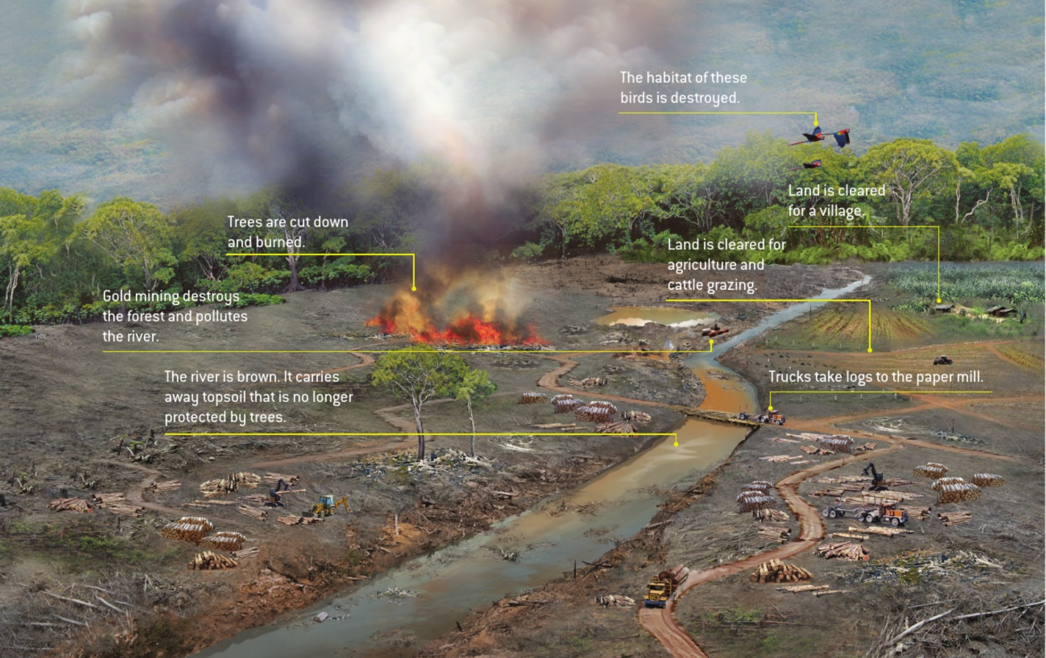

WORD DETECTIVE

2 Boggle

Use the letters provided to make as many words as possible.

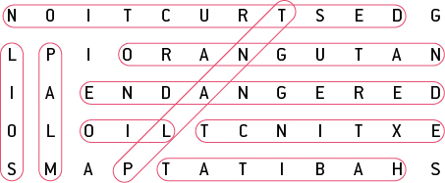

6.5 Science as a human endeavour: Isolated populations can be used as case studies

Literacy support worksheet answers (pages 110–111)

Isolated populations

1 As you can see from the photograph on the next page, Easter Island is not completely treeless. There are certain locations where trees have returned to the ecosystem.

a Look carefully at the map below, especially near Hanga Roa. How can you tell that humans live on Easter Island?

There is evidence that humans live near Hanga Roa because of the roads and an airport.

b Can you think of any way these trees may have naturally returned to Easter Island?

Student responses will vary, but may include seeds from the original trees germinating, seeds floating to the island on the sea, birds having brought the seeds to the island etc.

WORD DETECTIVE

2 Match-a-word

Draw a line from the words to their meanings.

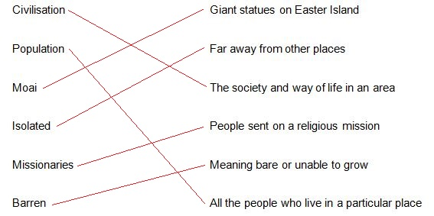

6.6 Science as a human endeavour: Environments can be responsibly managed

Literacy support worksheet answers (pages 112–113)

Managing ecosystems

1 What are ‘green wedges’ or ‘green belts’?

Green wedges or green belts are undeveloped land set aside within a city as a way of ensuring there are green areas with plants and animals within suburbs and cites.

2

a What are ‘green corridors’?

Green corridors are sections of bushland or grassland that often link green belts or wedges.

b Why are ‘green corridors’ important to animals and humans?

Green corridors allow animals to move from one location to another, through farmland or developed areas. Young animals can use these corridors to move out and form their own territories. These areas benefit farmers by acting as windbreaks and shelter belts; they also provide natural environments for humans to enjoy.

3 Look at the picture of the ‘sporting precinct’ in Melbourne. Describe the benefits of this ‘green wedge’ to animals.

Animals can live quite safely in this green wedge, which is also linked with green corridors. There appears to be plentiful water and more than likely food sources.

4 Why are National Parks so important?

National parks and reserves are one of the best ways to help protect endangered species and ecosystems. Here animals and plants can live safely without habitat destruction.

5 What is a ‘seed bank’ or ‘seed vault’?

Seed banks or vaults are places that classify and store seeds of important crop plants.

WORD DETECTIVE

6 Draw and label

a Apply your knowledge of ways to protect ecosystems by drawing and labelling a bird’s eye view diagram of your neighbourhood. Use the phrases below as some of your labels.

Student answers will vary.

b Describe where you have used the phrases above and why by completing the following sentences.

I designed a ‘green belt’ …

Student answers will vary.

I designed a ‘green corridor’ …

Student answers will vary.

I designed a ‘green wedge’ …

Student answers will vary.

6.7 Science as a human endeavour: Modern land managers use traditional Indigenous techniques

Literacy support worksheet answers (pages 114–115)

Indigenous techniques for managing ecosystems

1 Fill in the positive and negative effects of the firestick farming practice of Indigenous Australians in the table below. Many of the positive effects can be found in the text.

|  |  |  |  |
| --- | --- | --- | --- |
| Effects of firestick farming on humans | | Effects of firestick farming on the ecosystem | |
| Positive (Hint: think about hunting and the effects on plants and animals) | Negative (Hint: think about the dangers of fire and pollution) | Positive (Hint: think about hunting and the effects on plants and animals) | Negative (Hint: think about ecosystems and the effects on animals) |
| Student responses will vary but could include: hunting becomes easier, new shoots encourage more herbivores etc. | Student responses will vary but could include: fire may cause death or injury, waterways could become polluted from ash etc. | Student responses will vary but could include: firestick farming clears undergrowth, which could reduce unplanned bushfires, eventually provides new shoots for herbivores etc. | Student responses will vary but could include: the unnatural destruction of the ecosystems, death and injury caused to animals etc. |

WORD DETECTIVE

2 Crossword

Use the clues to fill in the crossword.

